Revision 2: CPU, languages and the internet - Student booklet
Y11 - Cambridge IGCSE Computer Science 0478 | Exam revision
Name: _______________________________ | Date: _____________

- Learn sections are your revision notes: read them carefully, then do the task straight after.
- Task 1 is a closed-book recall test - do it from memory first.
- Questions with a paper reference are real Cambridge 0478 questions. Your teacher will share the answers.
Task 1 Recall test on Revision 1 (closed book) [10 marks]
# | Question | Answer
1 | Convert the denary number 77 into 8-bit binary.
2 | Convert the binary number 11110010 into hexadecimal.
3 | What is the term for when the result of a binary addition is too large to store in the bits available?
4 | Convert −20 into 8-bit two's complement.
5 | Give one effect of a logical right shift of one place.
6 | Which part of a packet holds the packet number?
7 | Give one reason parallel transmission is not used over long distances.
8 | Which error detection method sends a copy of the data back to the sender?
9 | Is a check digit used for data entry or for data transmission?
10 | In symmetric encryption, how many keys are used?
Learn The CPU
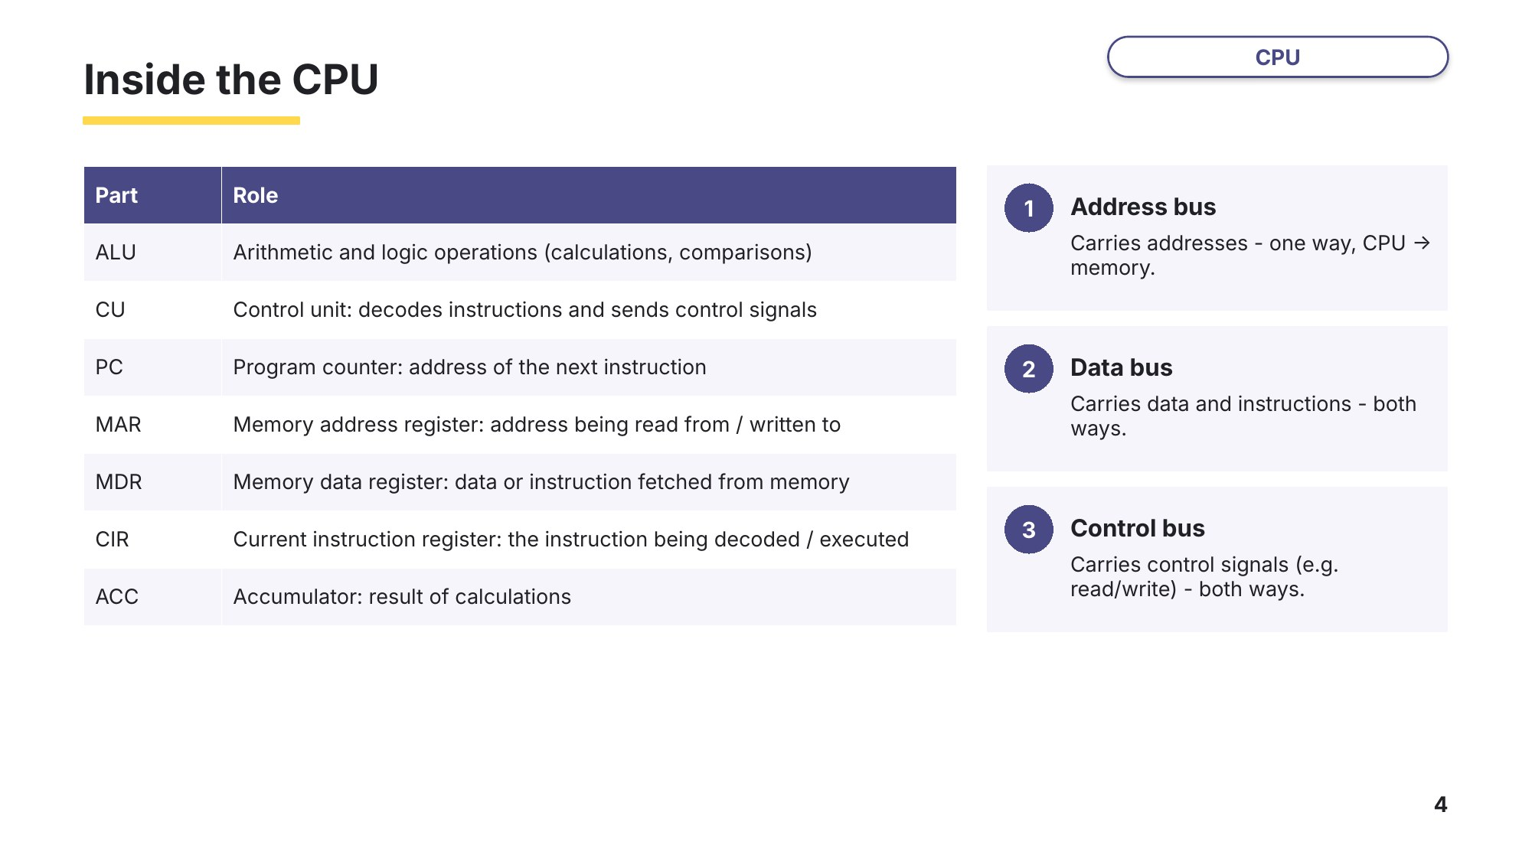
Slide 4 - Inside the CPU
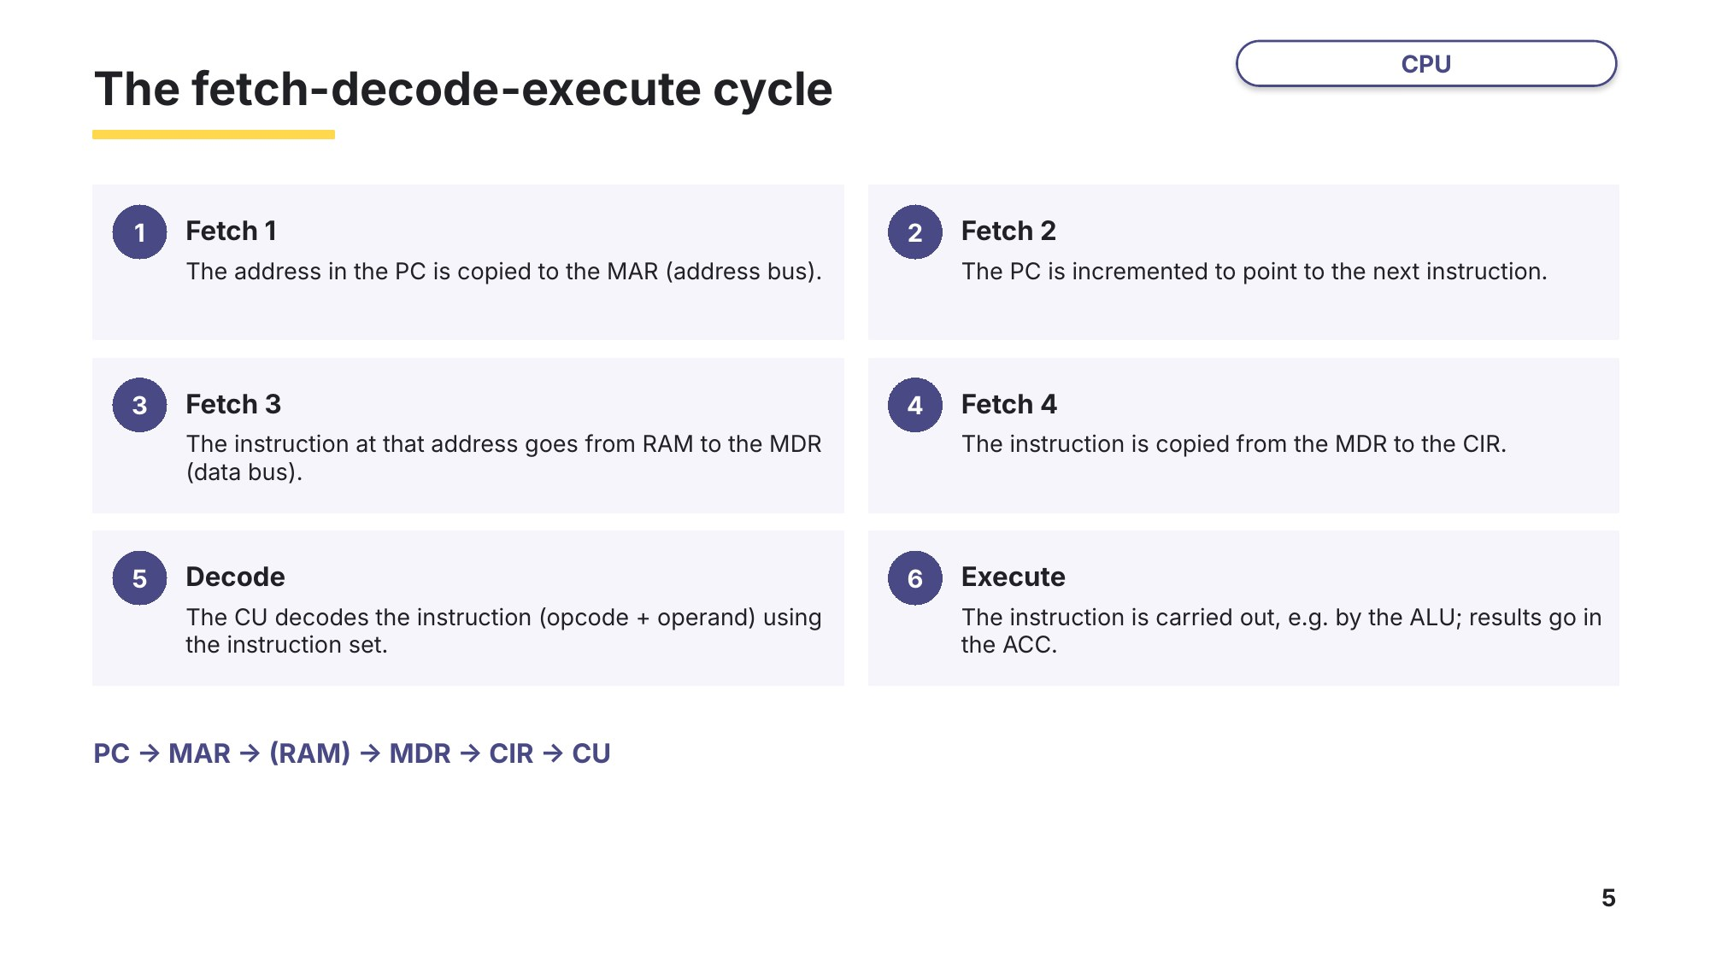
Slide 5 - The fetch-decode-execute cycle
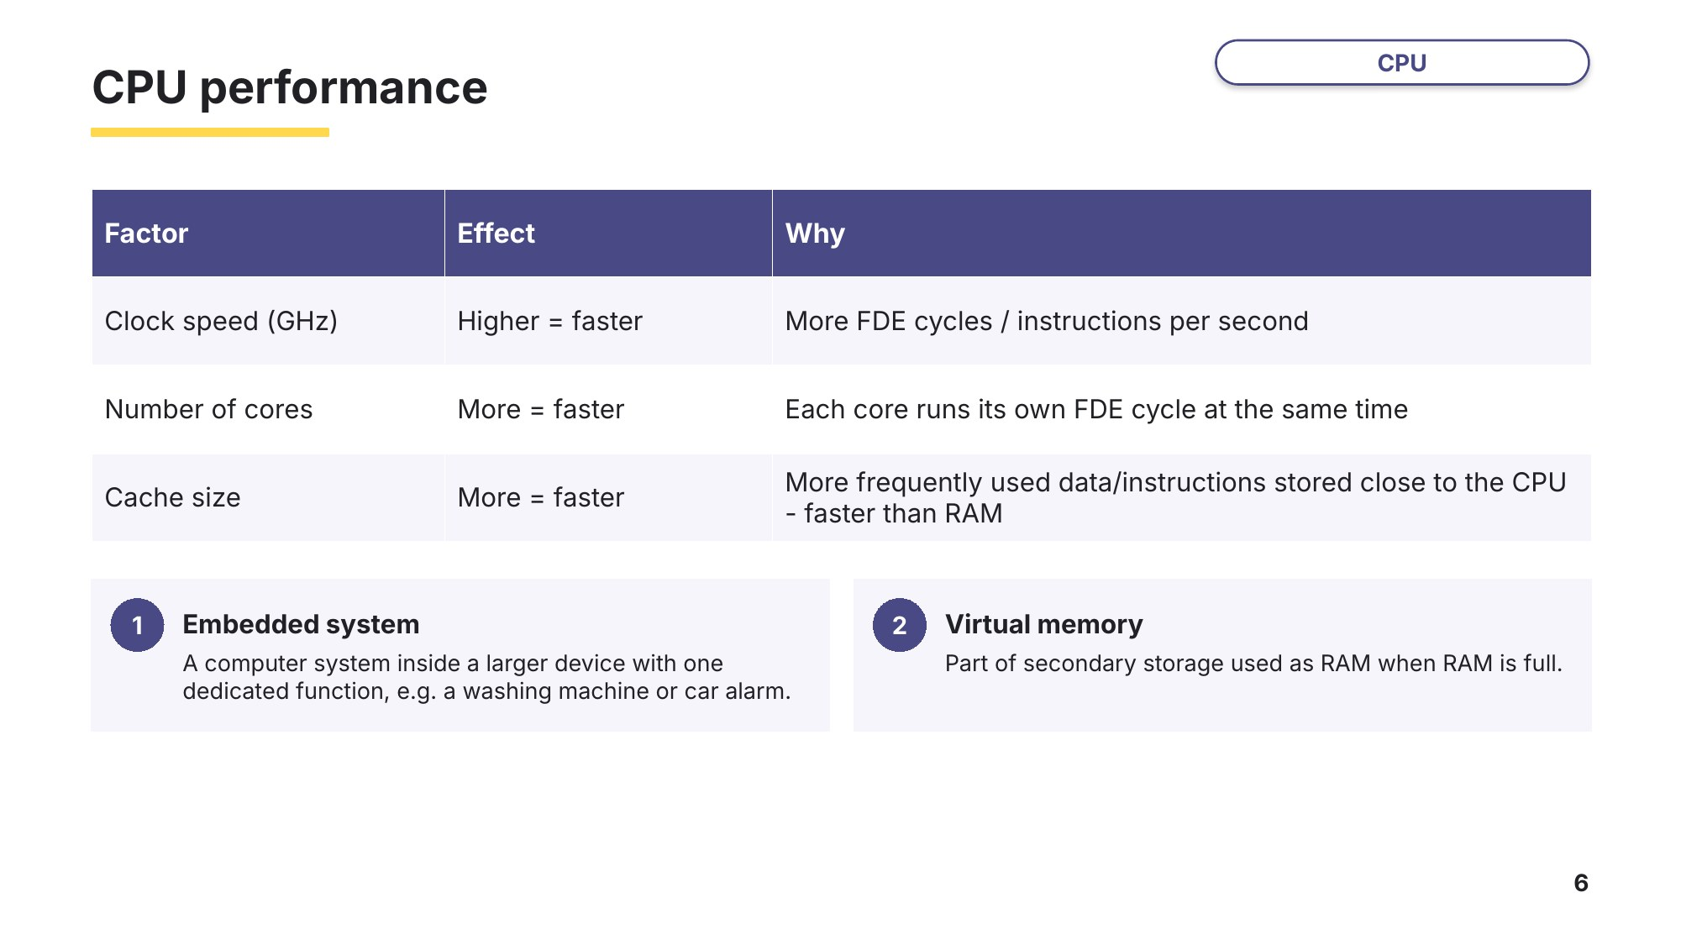
Slide 6 - CPU performance
Task 2 The CPU and the FDE cycle [22 marks]
2A Registers, cores and cache
0478/12 February/March 2024 Q2
A computer has a central processing unit (CPU). The CPU includes the registers: program counter (PC), memory address register (MAR), memory data register (MDR), accumulator (ACC) and current instruction register (CIR).
(a) The table contains five statements about the role of registers in the fetch–decode–execute cycle of a CPU. Two of the statements are not correct. Identify the letter of each incorrect statement. Suggest a corrected statement for each. [4]
Letter | Statement
A | PC stores the address of the next instruction to be accessed
B | MAR stores the instructions of the program that is running
C | MDR stores the data passed to it from the PC
D | ACC stores the result of each calculation
E | CIR stores the instruction currently being executed
Incorrect statement 1 …… Corrected statement

Incorrect statement 2 …… Corrected statement

(b) The computer has a single core 3.5 GHz processor and an 8 kB cache.
(i) State what is meant by a 3.5 GHz processor. [1]

(ii) The CPU is changed to a dual-core 3.5 GHz processor. Explain how the number of cores affects the performance of a CPU. [2]

(iii) The amount of cache is increased to 64 kB. Explain how the amount of cache affects the performance of a computer. [2]

(c) The computer has both primary and secondary storage.
(i) Random access memory (RAM) is one example of primary storage. Describe what is meant by RAM. [2]

(ii) Read only memory (ROM) is another example of primary storage. ROM often stores the start-up instructions for a computer. Identify one other item of data that is commonly stored in ROM. [1]

(iii) Some computers make use of virtual memory. State the purpose of virtual memory. [1]

2B Decode, execute and buses
0478/11 October/November 2024 Q5(b)-(e)
A central processing unit (CPU) performs the fetch–decode–execute (FDE) cycle.
(a) Describe what happens at the decode stage of the cycle. [3]

(b) Give one register in the CPU that is used in the execute stage of the cycle. [1]

(c) Buses are used in the CPU to transmit data through the FDE cycle. Circle three buses that are used in the CPU. [3]
fetch | address | register | execute
data | decode | calculation | central
value | binary | control
(d) A user changes their CPU from one with a dual core and a clock speed of 2.4 GHz to one with a dual core and a clock speed of 3.5 GHz. Explain the effect this change will have on the performance of the CPU. [2]

Learn Languages and translators
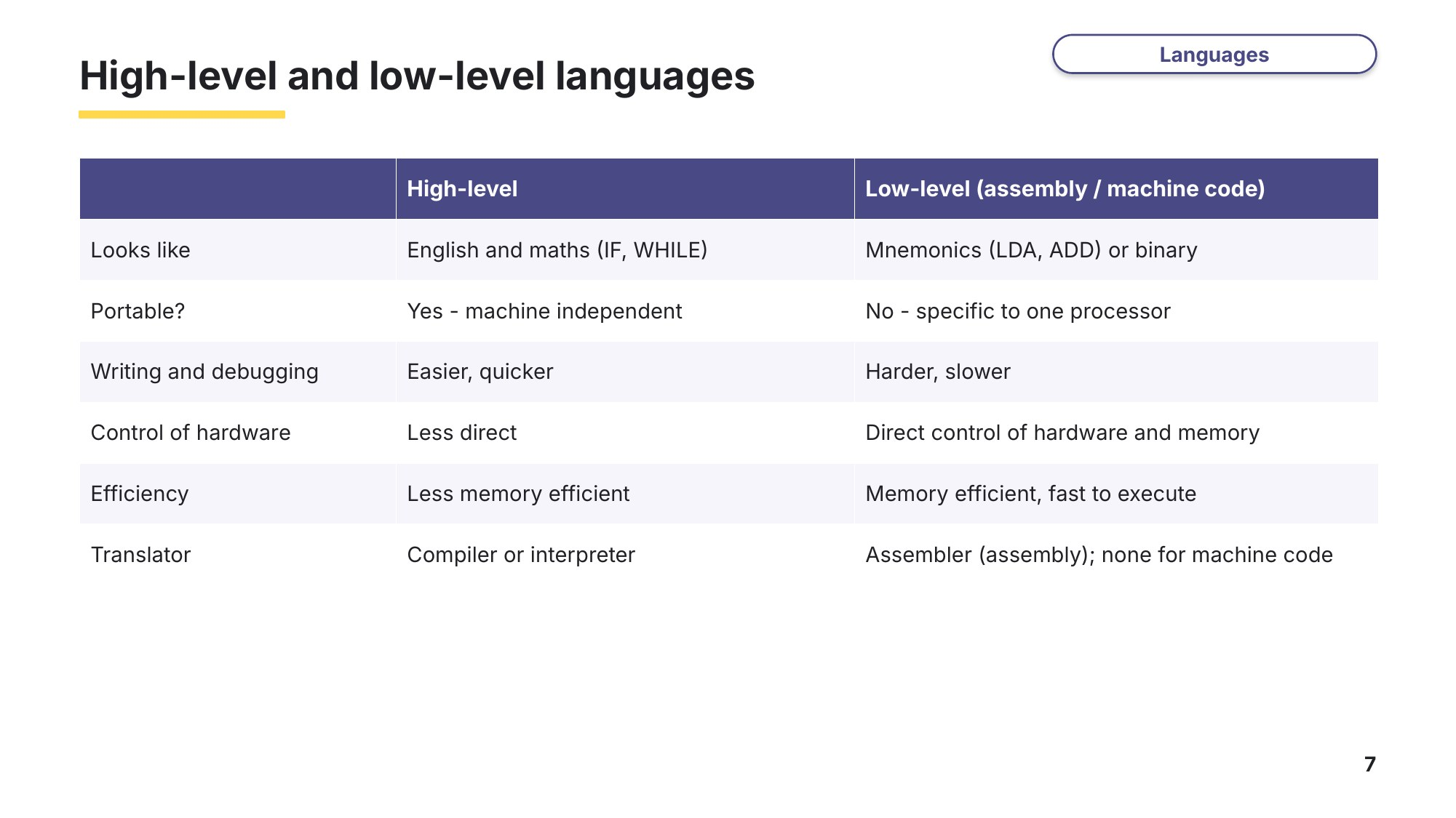
Slide 7 - High-level and low-level languages
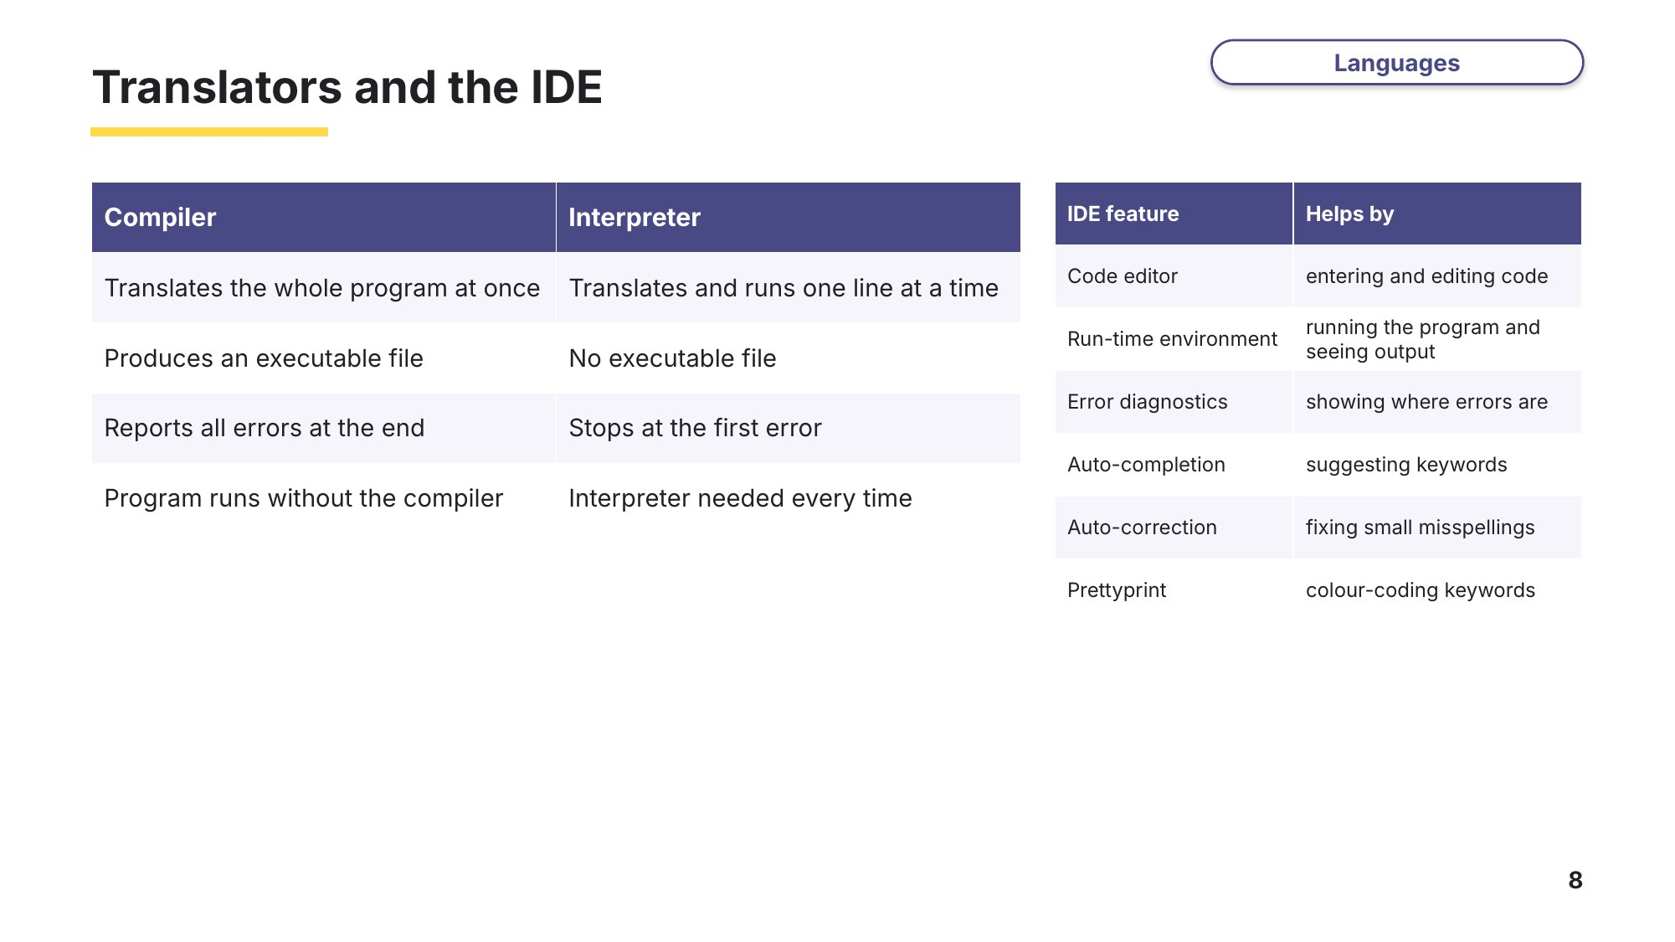
Slide 8 - Translators and the IDE
Task 3 Languages, translators and IDEs [17 marks]
3A Low-level languages
0478/11 May/June 2023 Q7
A programmer uses a low-level language to write a computer program for a vending machine.
(a) Describe what is meant by a low-level language. [2]

(b) Give two reasons why the programmer would choose to write the computer program in a low-level language instead of a high-level language. [2]
1

2

3B Assembly language and the IDE
0478/11 October/November 2024 Q6
A computer programmer uses assembly language to create a computer program for an embedded system in a washing machine.
(a) State what is meant by an embedded system. [1]

(b) Give the name of the translator that will be used for the program. [1]

(c) The washing machine needs to display error codes on a small screen if there is a problem with the washing machine. The error codes are stored as binary. The binary numbers are too long to be displayed on the washing machine. State how the error codes could be reduced in length to be displayed on the screen. [1]

(d) Give one benefit to the programmer of using assembly language to write the program. [1]

(e) The programmer uses an integrated development environment (IDE) to write the program. A built-in translator to convert the program into machine code is one way that the IDE helps the computer programmer. Describe three other ways the IDE can help the programmer. [6]
1

2

3

3C Compilers and interpreters (exam-style)
A student is writing a game in a high-level language. Give three differences between a compiler and an interpreter. [3]
1

2

3

Learn The internet
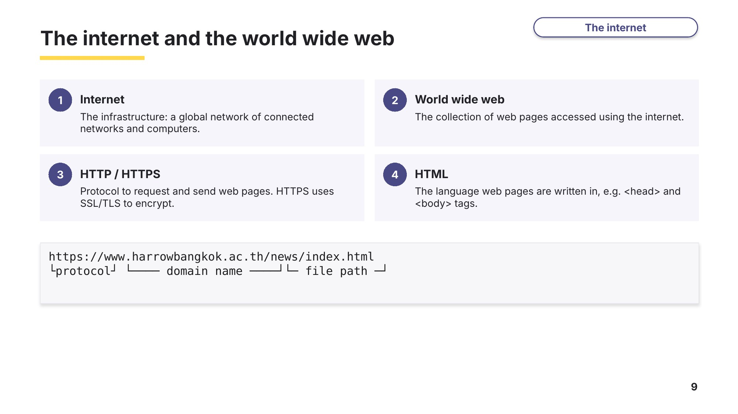
Slide 9 - The internet and the world wide web
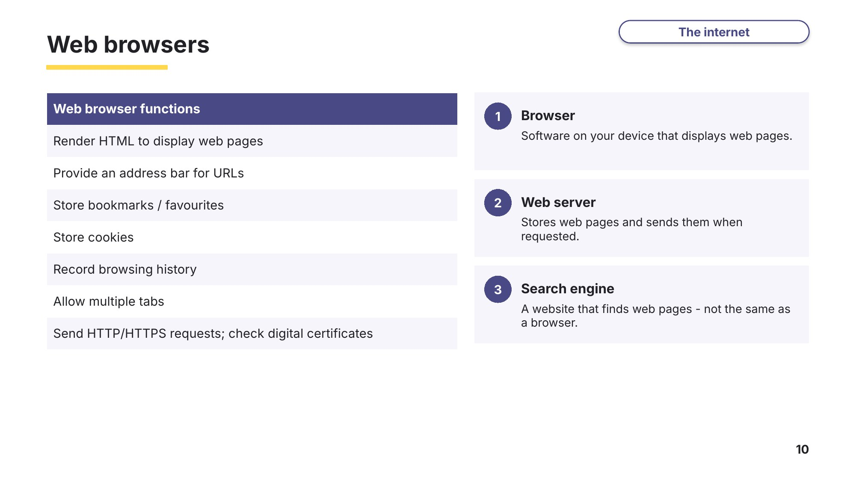
Slide 10 - Web browsers
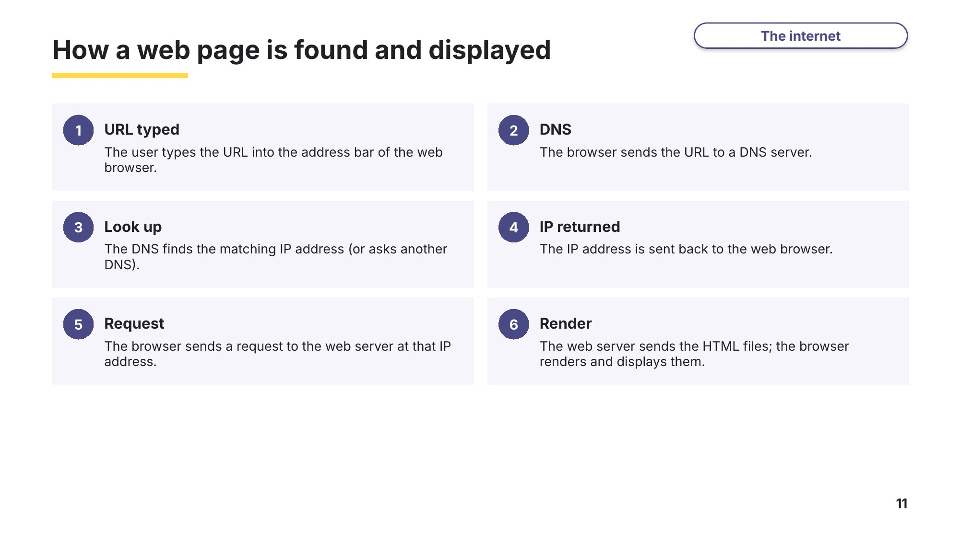
Slide 11 - How a web page is found and displayed
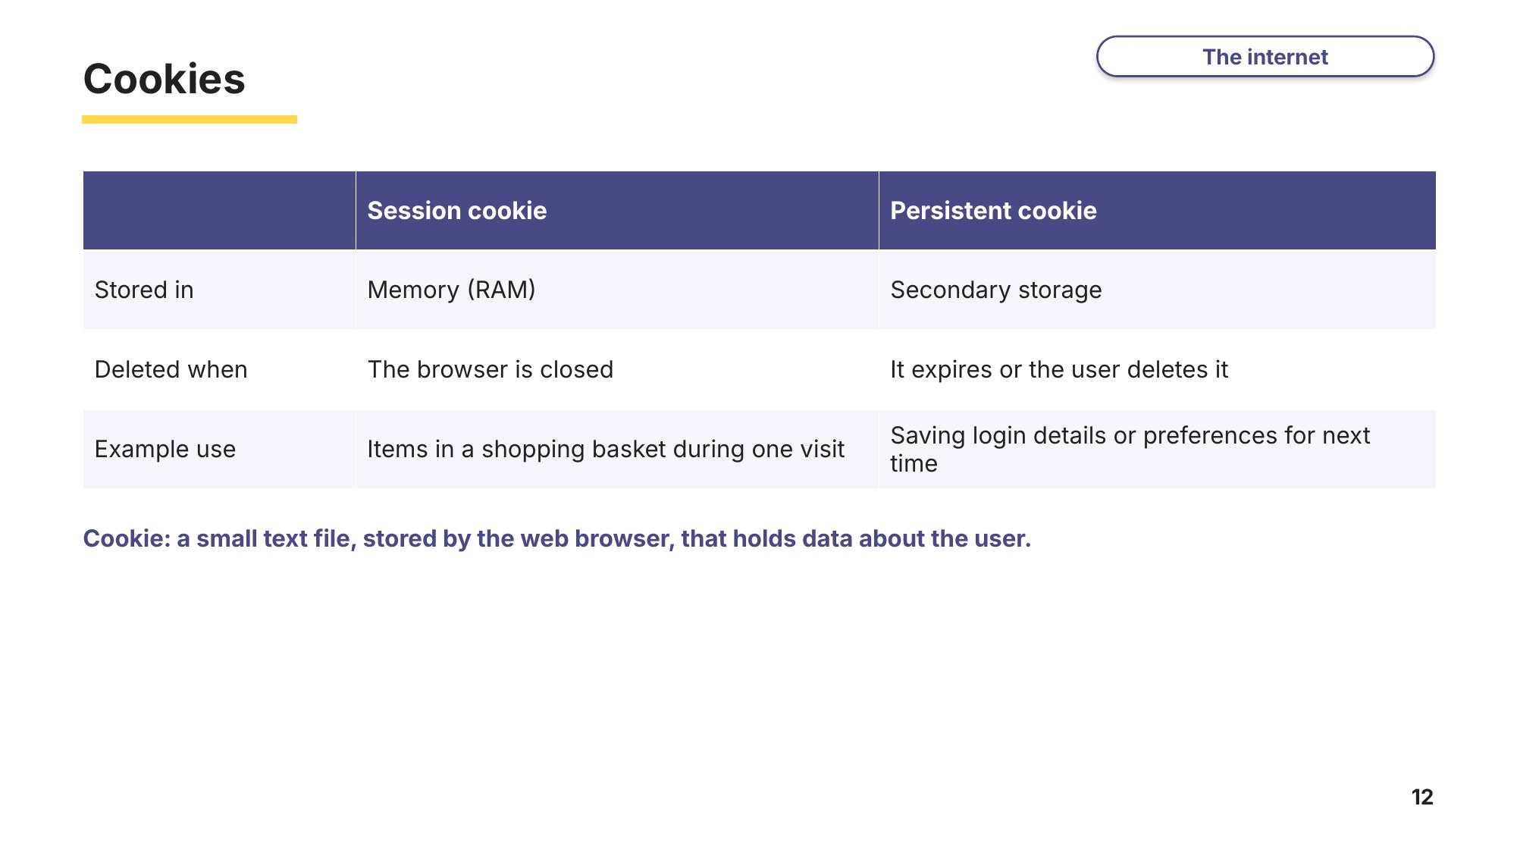
Slide 12 - Cookies
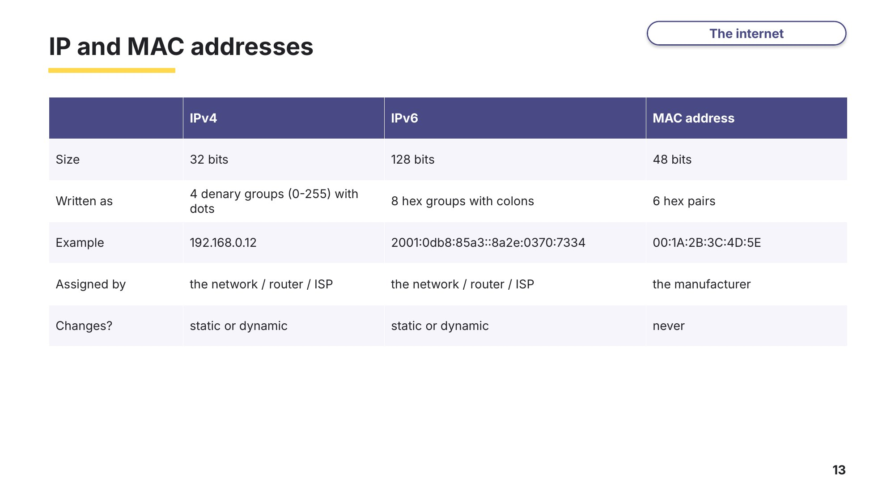
Slide 13 - IP and MAC addresses
Task 4 The internet, browsers and cookies [31 marks]
4A Web browser functions
0478/13 October/November 2023 Q4
An employee uses a web browser on their computer.
(a) Describe the main purpose of a web browser. [2]

(b) The employee wants his payment details to be automatically filled in when he buys products using the internet. Identify the function of a web browser that could be used for this purpose. [1]

(c) The employee wants to be able to quickly access websites that he regularly uses. Identify the function of a web browser that could be used for this purpose. [1]

(d) The web browser uses the secure socket layer (SSL) protocol to transmit personal data securely over the internet. State how the SSL protocol secures the data for transmission. [1]

4B URLs, DNS and SSL
0478/12 October/November 2024 Q7
A student enters the uniform resource locator (URL) for a web page into their tablet computer.
(a) State what is meant by a URL. [1]

(b) Identify two different parts of a URL. [2]
1

2

(c) The student enters the URL into a piece of software that then displays the web page. Identify the name of this software. [1]

(d) Draw and annotate a diagram to show how the web page is located and retrieved to be displayed on the student’s tablet computer. [5]
(e) The data for the web page is transmitted using the secure socket layer (SSL) protocol. Complete the paragraph about the SSL protocol. Use only terms from the list. Not all terms need to be used. Some terms may be used more than once. [5]
encrypted | file server | hypertext markup language (HTML)
hypertext transfer protocol (HTTP) | operating system | search engine
unencrypted | URL | web browser
web server
The ………………………… asks the ………………………… to identify itself. The ………………………… sends back its digital certificate. The ………………………… authenticates the digital certificate. If it is authentic, ………………………… data transmission begins.
4C Cookies
0478/12 May/June 2023 Q6
(a) Complete the statements about cookies. Use the terms from the list. Some of the terms in the list will not be used. Some terms may be used more than once. [6]
compression | executable | hypertext markup language (HTML)
hypertext transfer protocol (HTTP) | image | internet protocol (IP) address
persistent | session | sound
text | uniform resource locator (URL) | web browser
web server
Cookies are small ………………………… files that are sent between a ………………………… and a ………………………… .
………………………… cookies are stored in memory and not in the user’s secondary storage.
When the web browser is closed a ………………………… cookie is lost, whereas a ………………………… cookie is not lost.
(b) Give three functions of a cookie. [3]
1

2

3

4D IP addresses
0478/12 May/June 2024 Q7(b)
A computer has both a media access control (MAC) address and an internet protocol (IP) address. An IP address can have an IPv4 or IPv6 format.
(a) Give an example of an IP address that has an IPv4 format. [1]

(b) Give two characteristics of the IPv6 format. [2]
1

2

Learn Cyber security
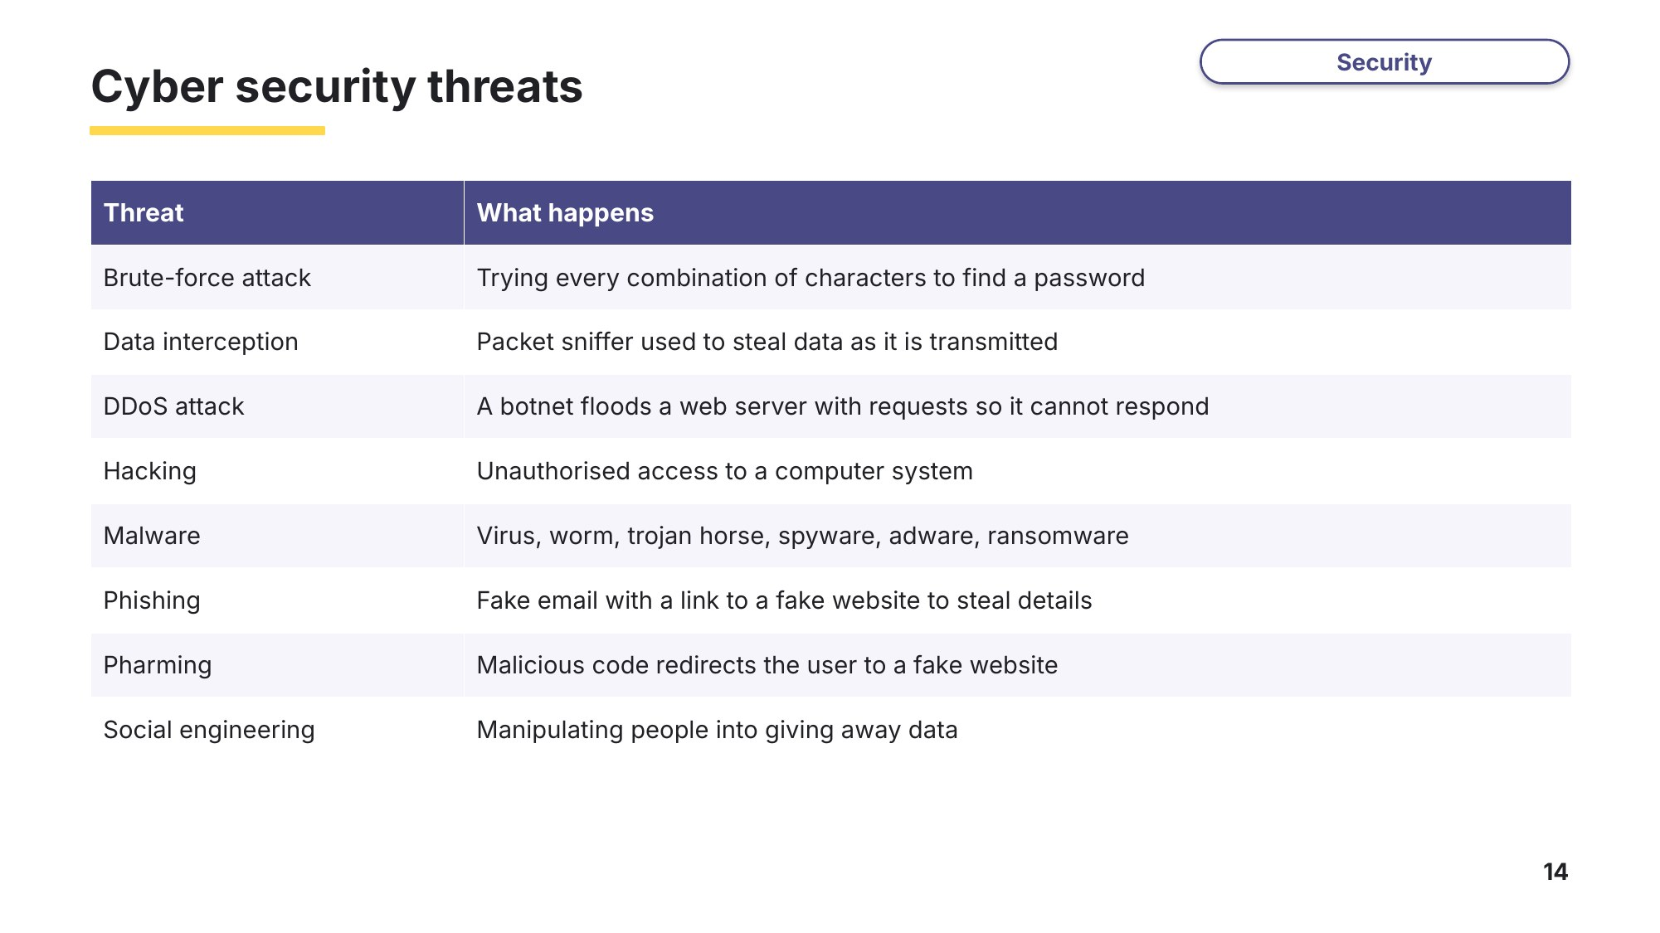
Slide 14 - Cyber security threats
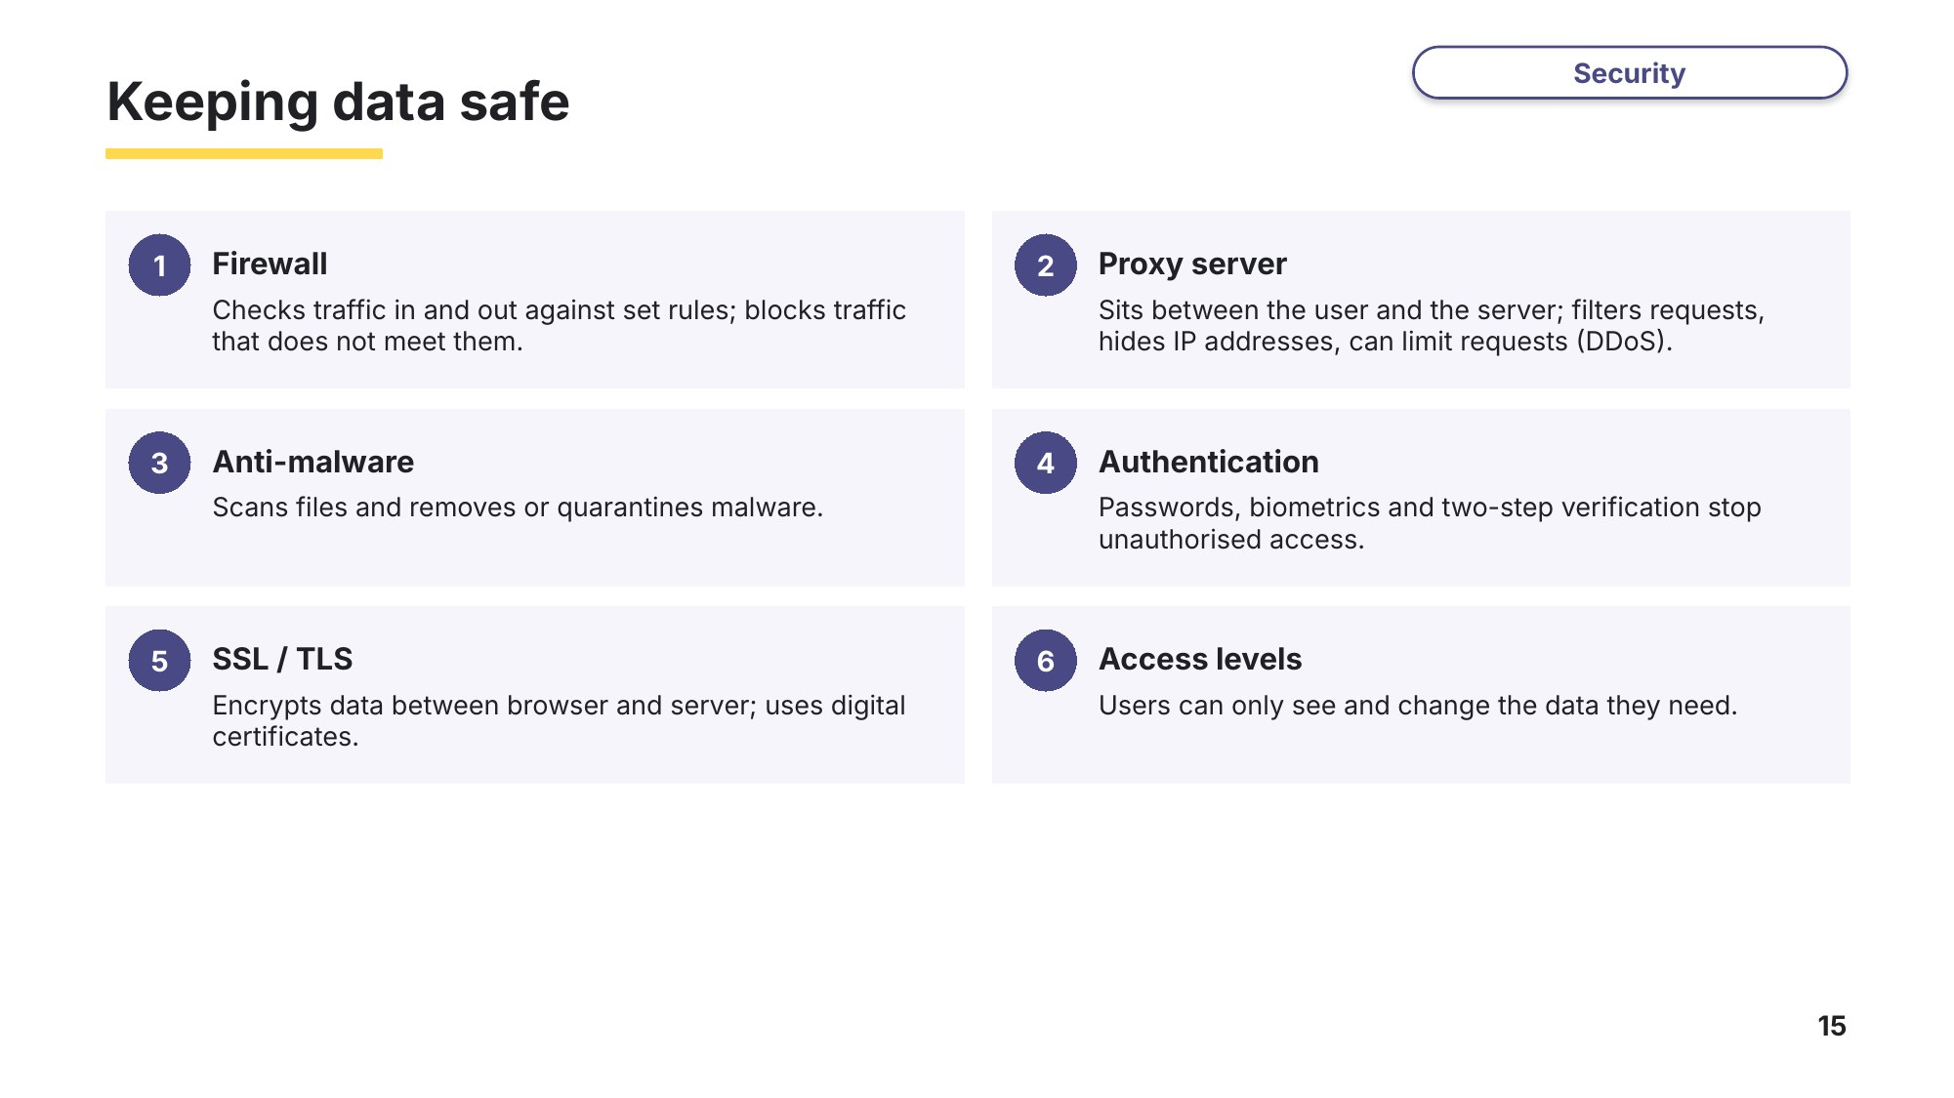
Slide 15 - Keeping data safe
Task 5 Cyber security [19 marks]
5A DDoS attack
0478/12 May/June 2023 Q7
A distributed denial of service attack (DDoS) is a cyber security threat.
(a) Draw and annotate a diagram to represent the process of a DDoS. [6]
(b) State two aims of carrying out a DDoS attack. [2]
1

2

(c) Give two security solutions that can be used to help prevent a DDoS attack being successful. [2]
1

2

5B Firewall
0478/11 October/November 2023 Q6
Draw and annotate a diagram to demonstrate how a firewall works. [4]
5C Proxy server
0478/13 May/June 2024 Q7(d)
A company uses a proxy server to help protect the web server and the network from cyber security threats.
(a) Give three cyber security threats that the proxy server can help protect against. [3]
1

2

3

(b) Identify two functions of the proxy server that can be used to help protect the web server and the network. [2]
1

2

Task 6 Extension: internet and security terms [11 marks]
6A Internet terms
0478/12 October/November 2023 Q9
The table contains terms and descriptions about the internet. Complete the table with the missing terms and descriptions. [6]
Term | Description
 | the collective name for all the web pages available
 | a small text file, stored by the web browser, that can store a user’s personal data
uniform resource locator (URL)
web server
 | the language used to create a website. Example tags are <head> and <body>
 | a protocol that is used to request and send web pages
6B Name the threat (exam-style)
Identify the cyber security threat described in each statement. [5]
Description | Threat
An email that looks like it is from a bank asks the user to click a link and enter their login details.
Software tries every possible combination of characters until it finds the password.
Malicious code installed on a computer redirects the user to a fake website, even when the correct URL is typed.
Software that locks or encrypts a user’s files and demands payment to release them.
A person phones an employee pretending to be from IT support and asks for their password.

